**Product Price Web Scraping and Analysis Project**

**Introduction**

In this project, we perform a web scraping analysis of product data from the online bookstore Books to Scrape. Using Python, we extract product information such as names, prices, and ratings. After collecting the data, we clean it, analyze key metrics like average price and rating distribution, and create visualizations to better understand pricing trends across different product ratings.

This project demonstrates a complete data workflow, including:

* **Web scraping** with BeautifulSoup
* **Data cleaning** with Pandas
* **Data analysis**
* **Data visualization** with Matplotlib and Seaborn

**Step One: Import Python Libraries**

We import the python libraries needed to scrape the website, organize the data, and create visualization.

**Step Two: Request the Website Data**

We use the requests library to fetch the HTML content of the website.

**Step Three: Parse the HTML**

We use BeautifulSoup to parse the HTML and prepare it for scraping product details.

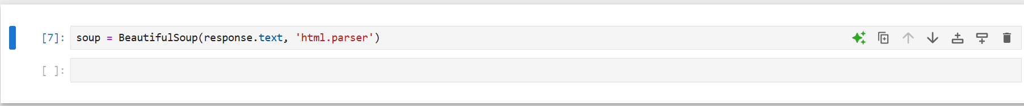

**Step Four: Extract Product Information**

We loop through the website content to pull product names, prices, and ratings. We also clean the price data to remove any unwanted characters like the pound symbol.

**Step Five: Create a DataFrame**

We turn the product data into a Pandas DataFrame to easily organize and analyze it.

**Step Six: Clean the Ratings**

We convert the text ratings into numbers so we can analyze them more easily.

**Step Seven: Analyze the Data**

We calculate the average product price and count how many products have each rating.

**Step Eight: Visualize the Data**

**Price Distribution**

This chart shows the distribution of product prices.

**Ratings Distribution**

This chart shows how many products have each rating

**Price by Rating**

This chart compares the prices of products across each rating

**Conclusion**

In this project, we successfully scraped product data from an online store, cleaned it, and analyzed it. We calculated the average price of products, explored the distribution of ratings, and visualized the relationships between product ratings and prices. This project demonstrates the complete workflow of web scraping, data cleaning, data analysis, and visualization using Python